Project Plan

For this project, we will be using the Rational Unified Process (RUP) model. We plan to develop the project iteratively through the four phases; Inception, Elaboration, Construction, and Transition. Our project plan is presented visually below.

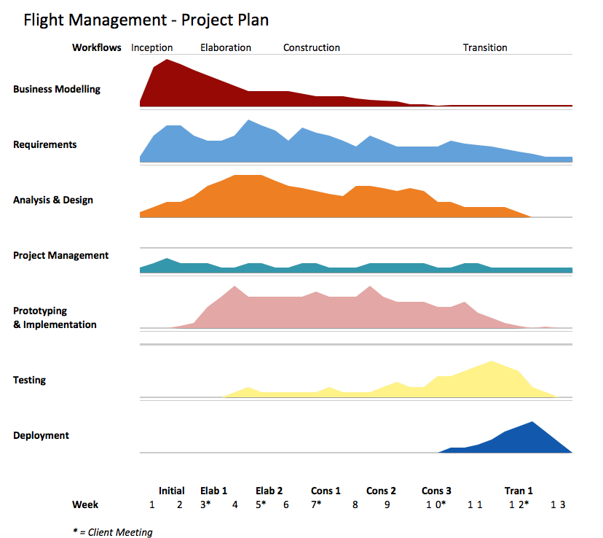

In the inception phase (weeks 1-3), our team objective is to obtain a scope and business case for the project and expand on the general requirements from the client. In this phase, we will also develop use cases. After these two weeks, we will have our first meeting with the client in week 3, which will begin the Elaboration Phase.

In the first block of this phase, we will seek to define specific requirements. We will also expand our understanding of our initial use cases, and add more if need be after the first client meeting. In addition to the use cases, we will present a prototype walkthrough to present to the client in the second client meeting in week 5. In the second elaboration block, we will further refine the requirements, as well as begin creating class diagrams to plan which classes are needed, as well as their association and inheritance.

At this point, we plan for most of the requirements and planning to be done, but do expect for them to be changed and some requirements added by the client in the future meetings. We will now begin constructing the program and start our first construction block. Using our Use Case diagrams and our UML Class diagrams, we will begin by constructing ‘skeleton’ files. Our main objective here is to get all of the classes and menu systems working, interacting, and functioning properly, before coding algorithms. To finish off this block, we will complete thorough testing on the program, and complete any bug reports or system failures.

Using our collected error reports from the previous construction block, we will begin our second construction block by fixing these errors and continuing to build the program. Our main objective here is to expand on the program’s functionality and key features. After most of the coding is done in this block, we will begin thorough testing. We will then create a detailed prototype to present to the client in week 10.

After we present the detailed prototype to the client in week 10, we will finalize the bulk of the construction phase. We anticipate that the client will want to add a few more system requirements and less important features, but most of the coding will be done by this point.

In the transition phase, we will prioritize testing and overall refinement of the program’s functionality. Our team plans to develop a beta system, which will allow thorough testing over a short period of time if given to many users. The bulk of the transition phase will be to deploy the project to the client including a final presentation of how to use it. This phase will finalize the project.